Masoner Module 1.2 Assignment

Csd-340

Link to GitHub Repository

<https://github.com/Ean1115/csd-340.git>

local directory screen shot

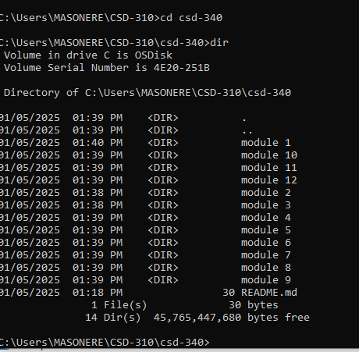

Screenshot of GitHub repository

